Practical Session 1
Develop a C program that demonstrates how a Linux operating system executes a command entered by a user that 1. Accept a Linux command as input. 2. Create a child process using fork(). 3. Execute the command in the child process using an appropriate exec() system call. 4. Allow the parent process to wait for the child using wait (). 5. Display the Process ID (PID) of both parent and child processes.
Steps:
- Open Ubuntu
- Install gcc,g++,valgrind,strace,git and gdb

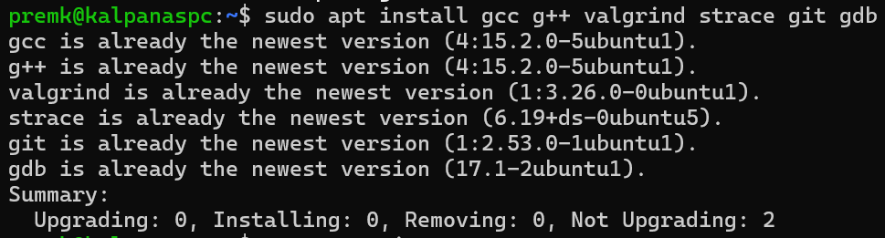

- Check whether all are installed correctly or not by viewing their versions

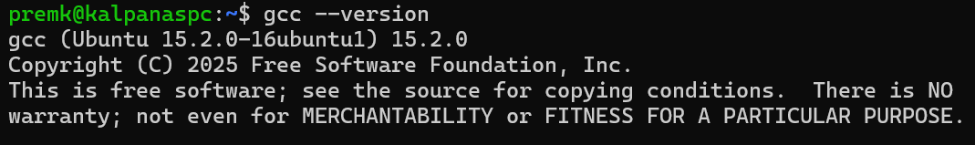

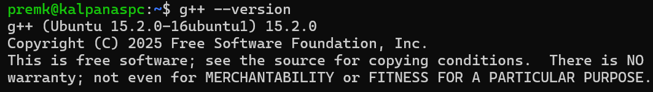

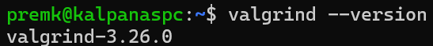

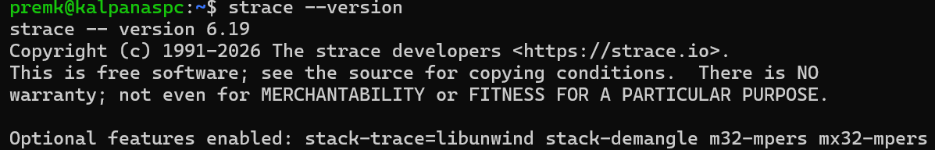

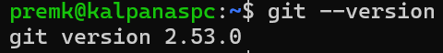
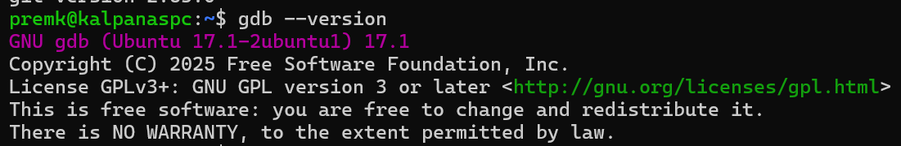
- Create a directory and change to that directory

premk@kalpanaspc:~$ mkdir skilling
premk@kalpanaspc:~$ cd skilling

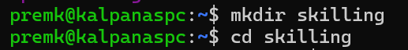

- Create 4 sub directories: src, include, tests, docs

premk@kalpanaspc:~/skilling$ mkdir src include tests docs
premk@kalpanaspc:~/skilling$ ls
docs include src tests
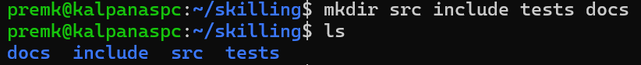

- Change to src directory and create a C program

premk@kalpanaspc:~/skilling$ cd src
premk@kalpanaspc:~/skilling/src$ nano prog1.c

Write the following code:
C Program
#include <stdio.h>
#include <stdlib.h>
#include <unistd.h>
#include <sys/types.h>
#include <sys/wait.h>
#include <string.h>

#define MAX_ARGS 20
#define MAX_LEN 100

int main() {
char command[MAX_LEN];
char *args[MAX_ARGS];
int i = 0;
printf("Enter a Linux command: ");
fgets(command, sizeof(command), stdin);
// Remove newline character
command[strcspn(command, "\n")] = '\0';
// Split command into arguments
args[i] = strtok(command, " ");
while (args[i] != NULL && i < MAX_ARGS - 1) {
i++;
args[i] = strtok(NULL, " ");
}
pid_t pid = fork();
if (pid < 0) {
printf("Fork failed.\n");
exit(1);
}
else if (pid == 0) {
// Child Process
printf("\nChild Process\n");
printf("Child PID : %d\n", getpid());
printf("Parent PID : %d\n", getppid());

execvp(args[0], args);
// Executes only if exec fails
perror("Execution failed");
exit(1);
}
else {
// Parent Process
printf("\nParent Process\n");
printf("Parent PID : %d\n", getpid());
printf("Child PID : %d\n", pid);
wait(NULL);
printf("\nChild process has completed execution.\n");
}
return 0;
}

To close Ctrl+O
Enter
Then Exit Ctrl+X
- Compile and run the program
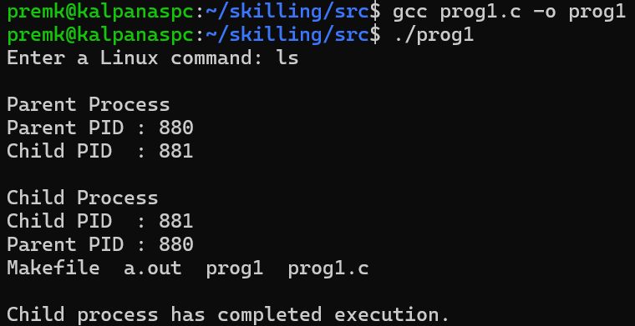

- Create a Makefile with the following code:

premk@kalpanaspc:~/skilling/src$ nano Makefile

CC = gcc
CFLAGS = -Wall -g

prog1: prog1.c
$(CC) $(CFLAGS) -o prog1 prog1.c

clean:
rm -f prog1

Ctrl +O
Enter
Ctrl + X

premk@kalpanaspc:~/skilling/src$ make

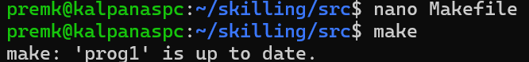

- Change directory and debug
premk@kalpanaspc:~/skilling/src$ cd ..
premk@kalpanaspc:~/skilling$ gdb ./prog1

(gdb) run
(gdb) break main

(gdb) exit

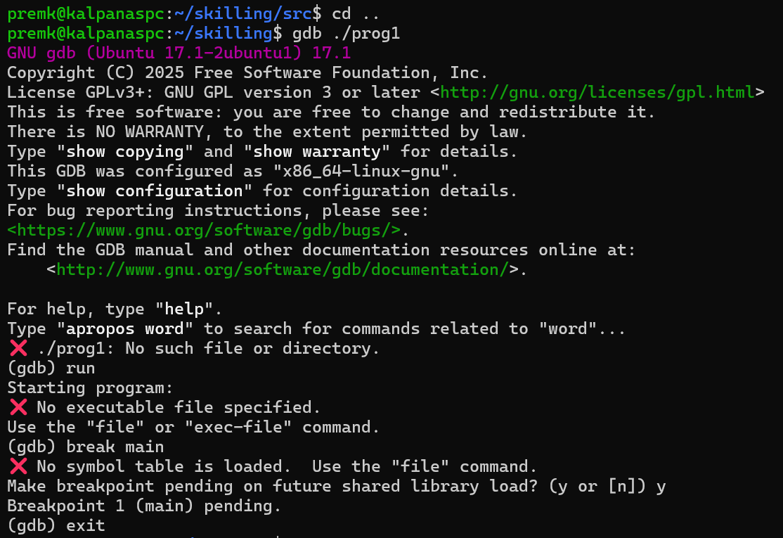
10. Change directory and install gh
premk@kalpanaspc:~/skilling$ cd src
premk@kalpanaspc:~/skilling/src$ sudo apt install gh
[sudo: authenticate] Password:
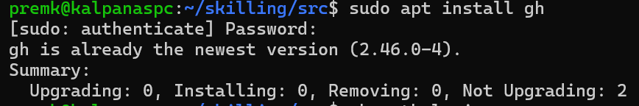
11. Now authenticate (log in) your GitHub account from the terminal.
premk@kalpanaspc:~/skilling/src$ gh auth login
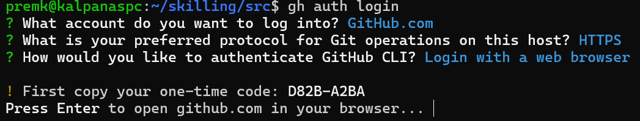

Open browser and type the following : https://github.com/login/device/
And enter the above one-time code:
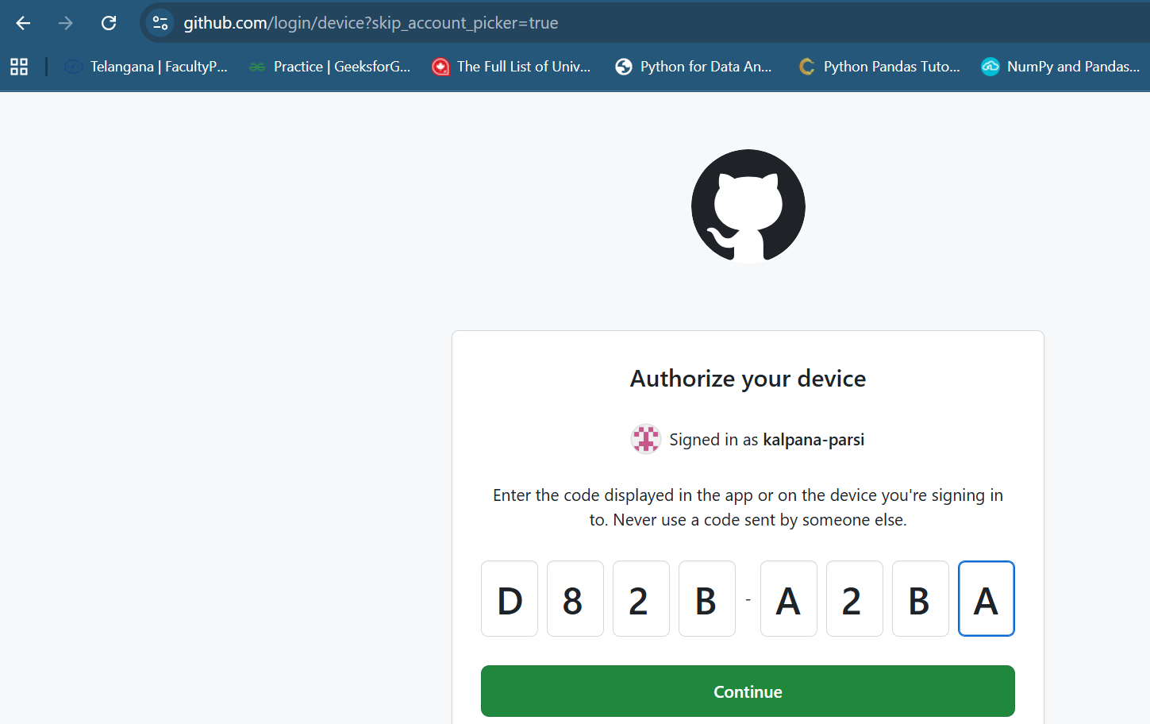

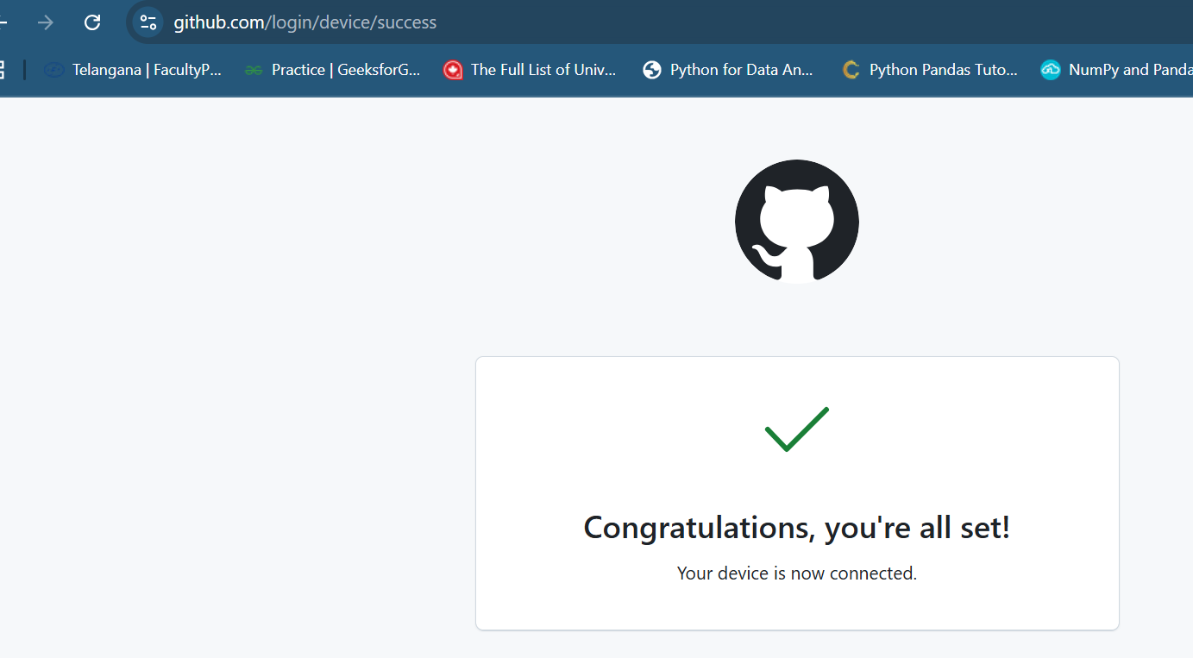
Once down we can view this
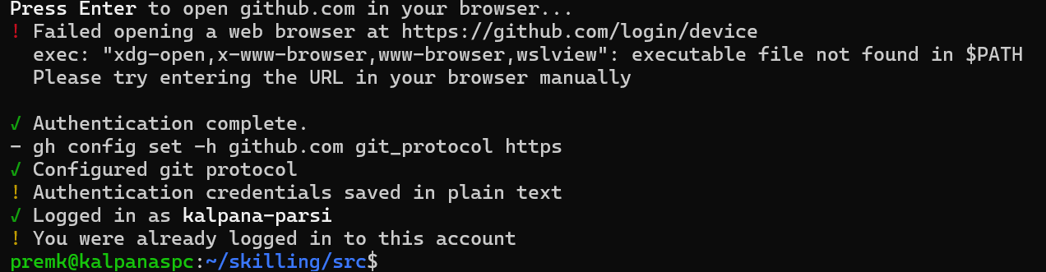
12. Create a repository in github with the name “skill1” to push/upload the c program created earlier.
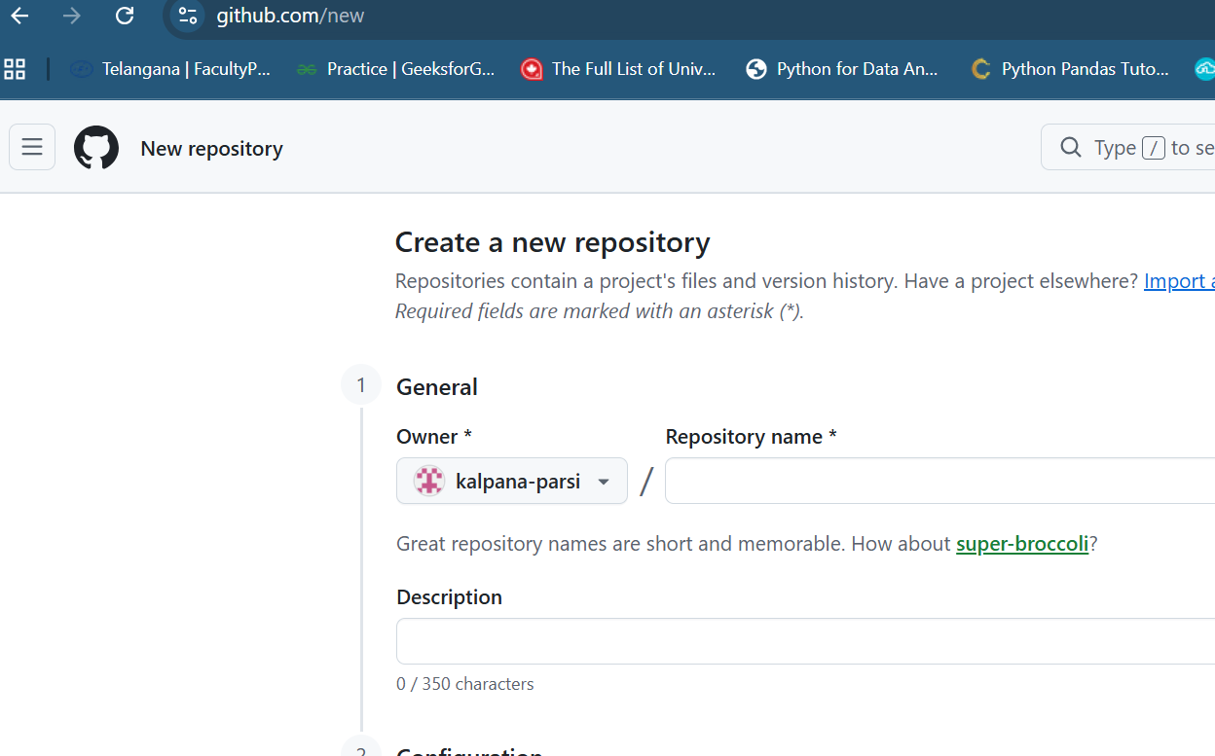
13. Now to add . files use the following command:
premk@kalpanaspc:~/skilling/src$ git add .
14. Then initialize git:
premk@kalpanaspc:~/skilling/src$ git init
Reinitialized existing Git repository in /home/premk/skilling/src/.git/
15. Now commit:
premk@kalpanaspc:~/skilling/src$ git commit -m "commit2"

[master (root-commit) 4f16fae] commit2
5 files changed, 69 insertions(+)
create mode 100644 Makefile
create mode 100644 README.md
create mode 100755 a.out
create mode 100755 prog1
create mode 100644 prog1.c
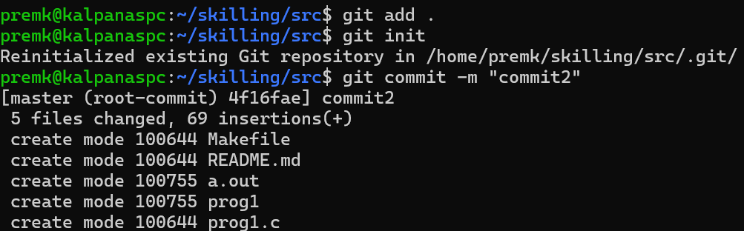
16. To push/upload the files into repository:
premk@kalpanaspc:~/skilling/src$ git branch -M main
premk@kalpanaspc:~/skilling/src$ git remote add origin https://github.com/kalpana-parsi/skill1.git
premk@kalpanaspc:~/skilling/src$ git push -u origin main
Enumerating objects: 6, done.
Counting objects: 100% (6/6), done.
Delta compression using up to 12 threads
Compressing objects: 100% (5/5), done.
Writing objects: 100% (6/6), 3.88 KiB | 3.88 MiB/s, done.
Total 6 (delta 0), reused 0 (delta 0), pack-reused 0 (from 0)
To https://github.com/kalpana-parsi/skill1.git
* [new branch] main -> main
branch 'main' set up to track 'origin/main'.
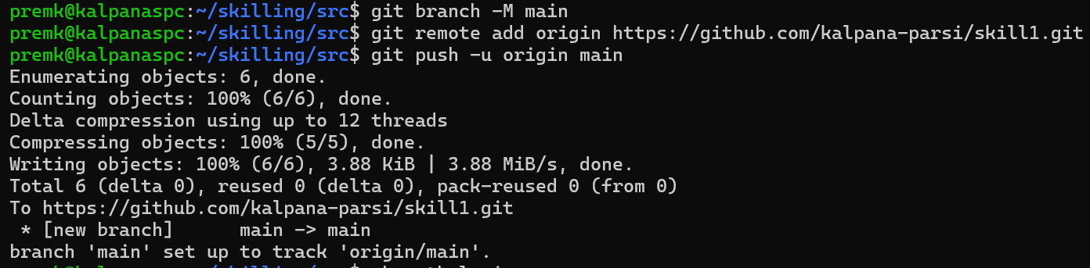
We can view the uploaded files in github repository
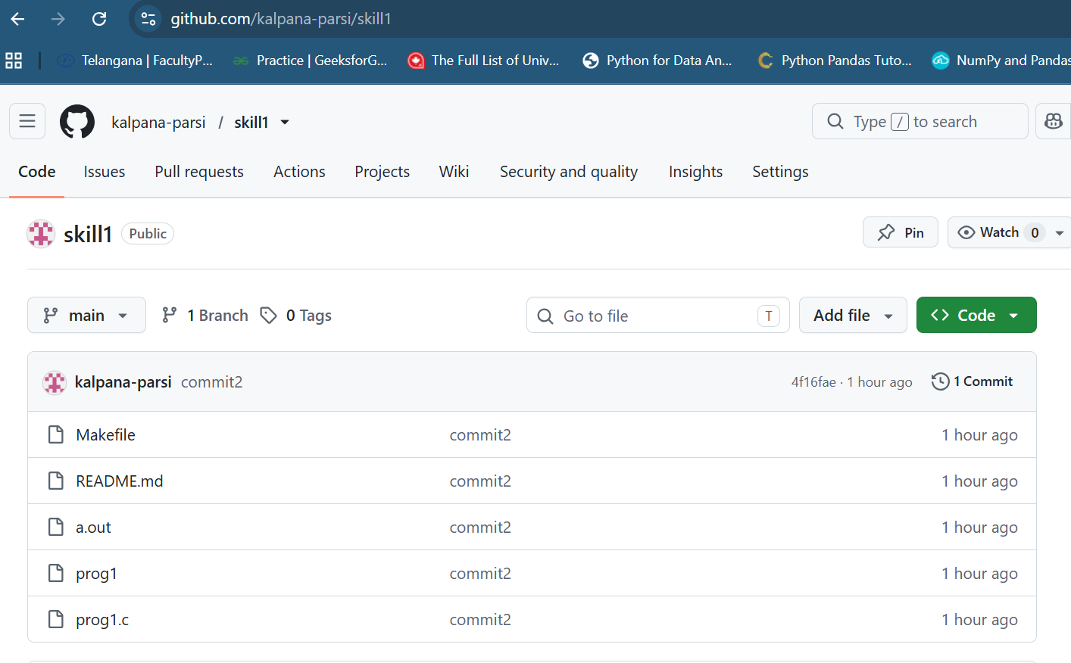

Using Linux terminal commands (uname, lscpu, lsblk, ps, top), investigate the relationship between hardware resources and operating system services. Prepare a report explaining how the OS abstracts CPU, memory, storage, and I/O devices.
Command | Purpose
uname -a | Displays Linux kernel and system information.
lscpu | Displays CPU architecture and processor details.
lsblk | Lists storage devices and partitions.
ps | Displays currently running processes.
top | Displays real-time system resource utilization.
